# Date vs total delay

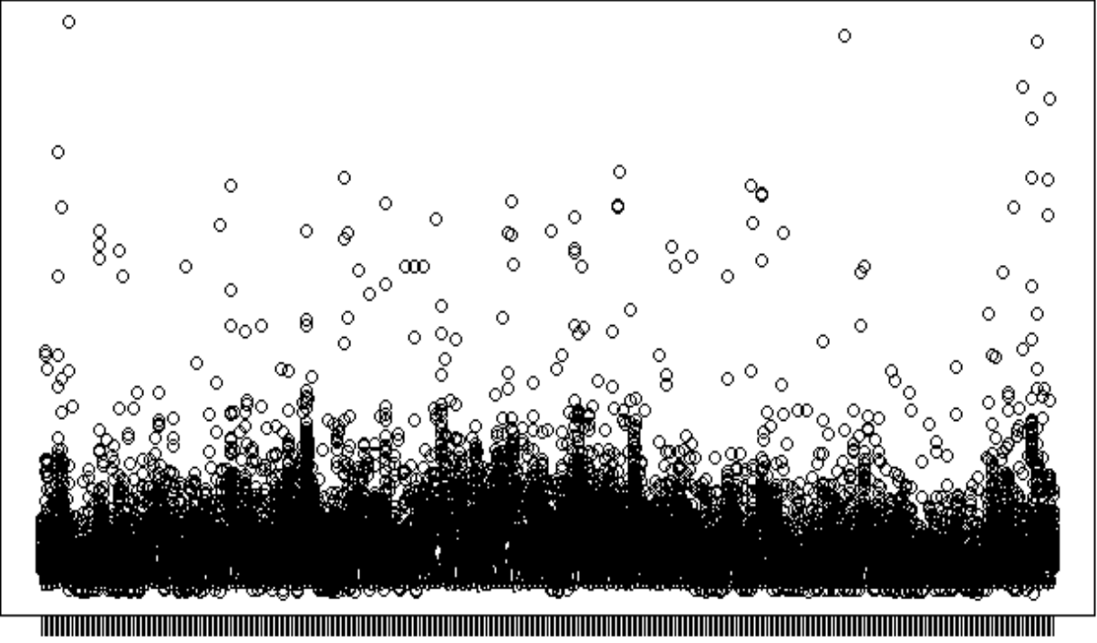

Date vs Weather delay

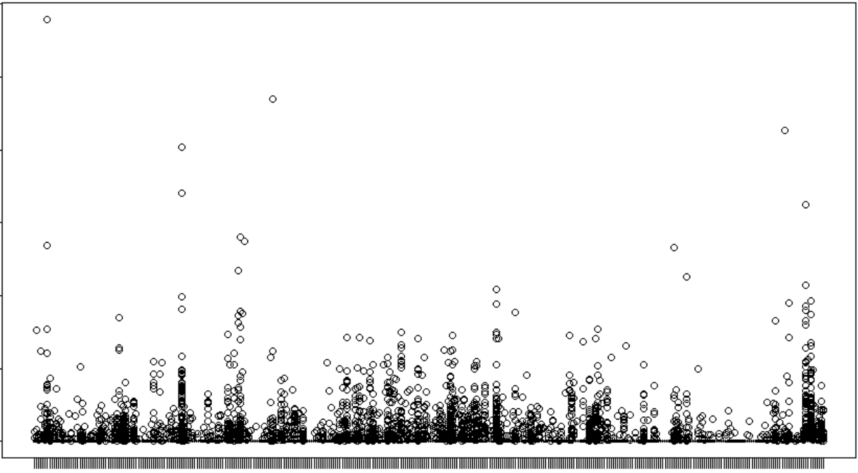

# Date vs NAS delay

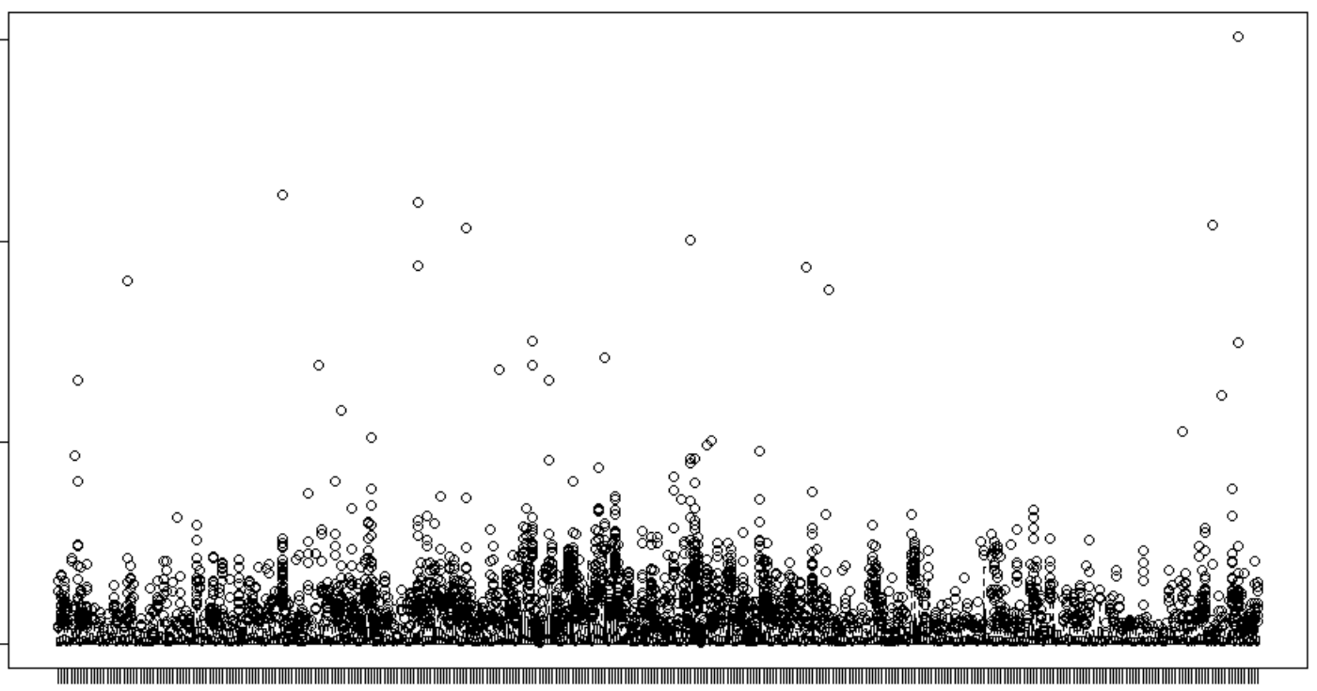

# FL_DATE VS SECURITY DELAY

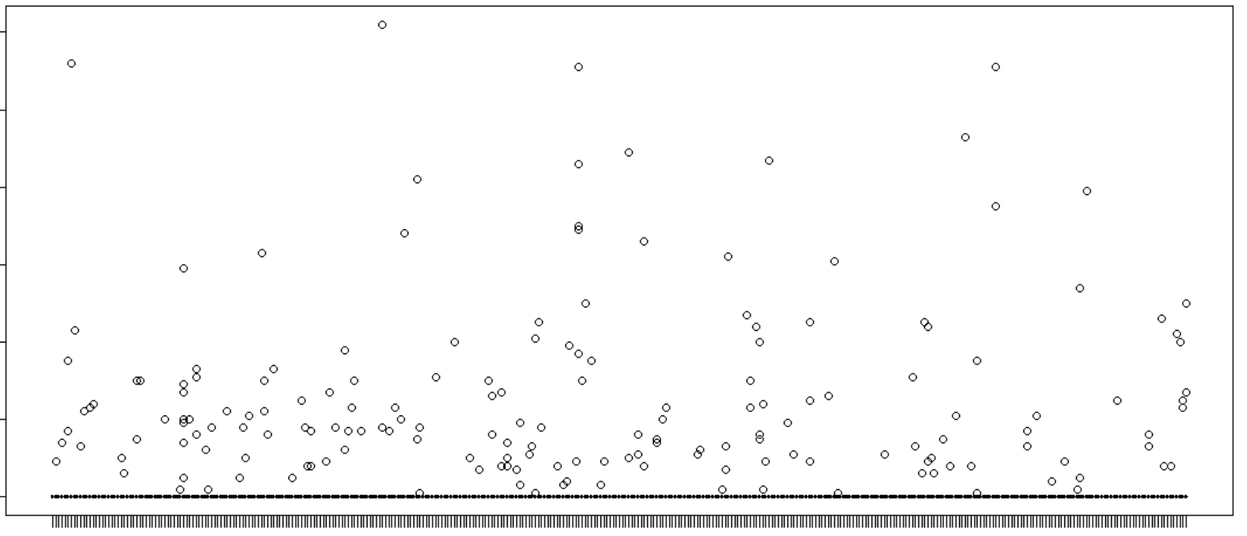

# CARRIER DELAY

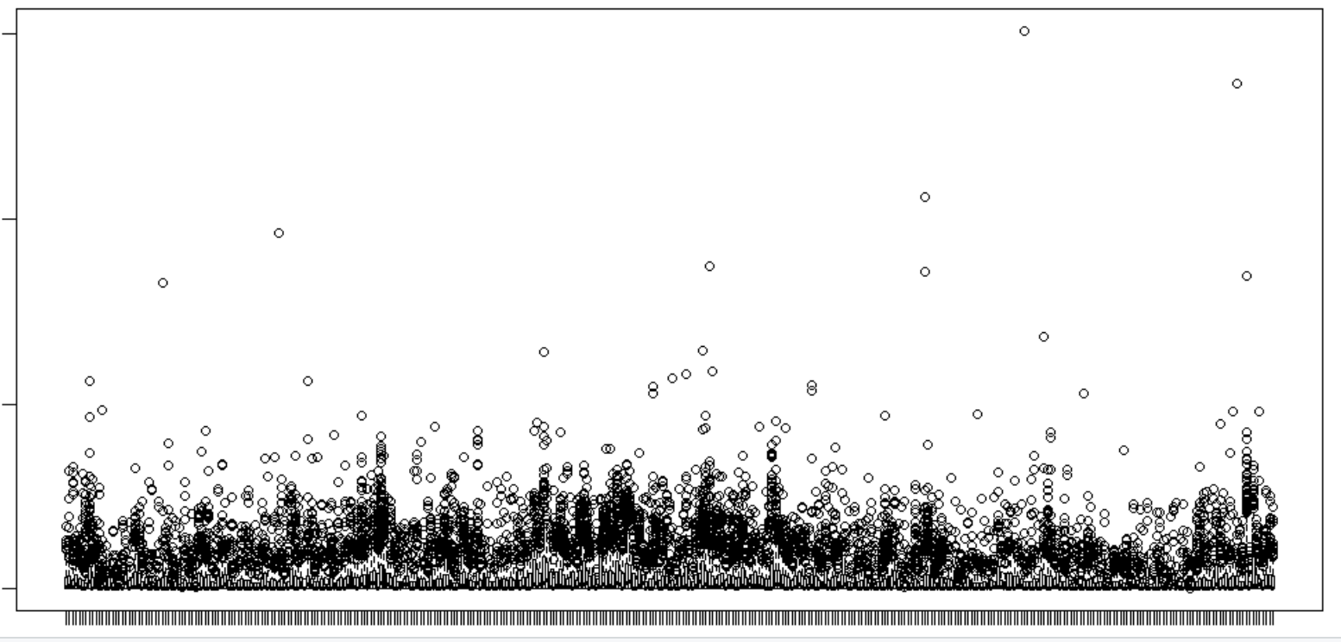

# OP_CARRIER vs delay in 2017

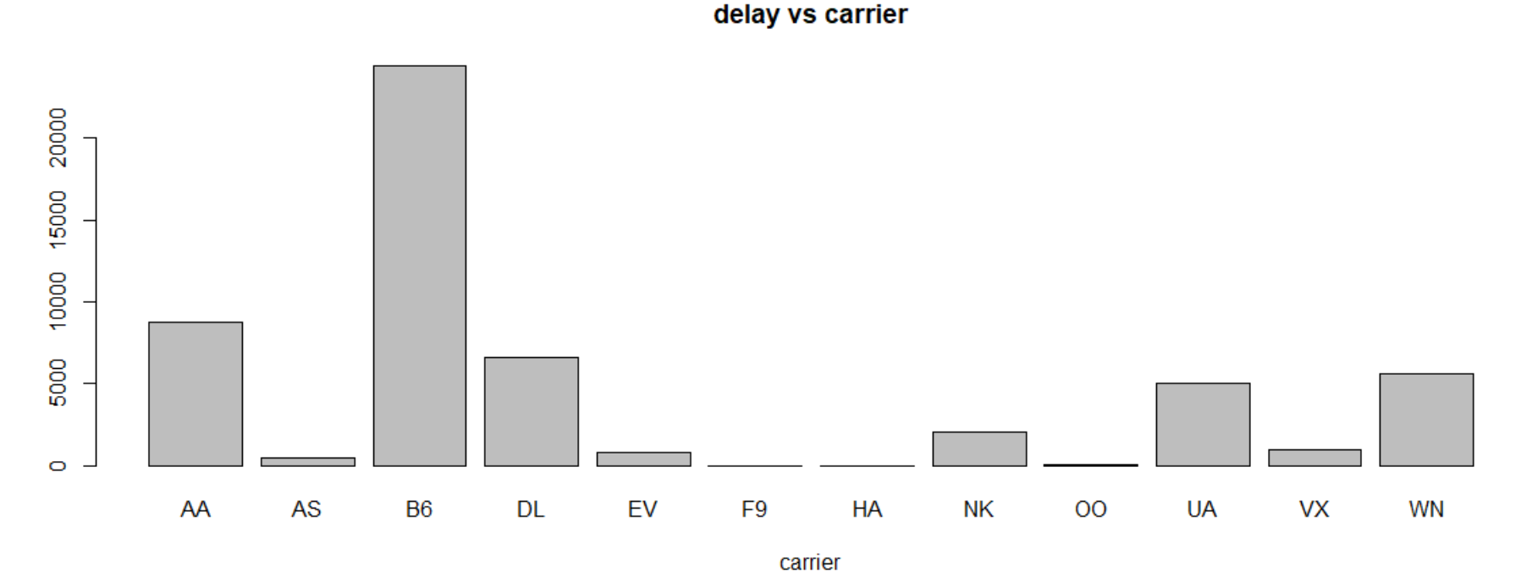

# Delay for BOS = ORIGIN per type

# Delay for BOS = DEST per type

# Cluster city delay for origin=BOS

# Cluster city delay for dest=BOS